Parcel Load Checklist

Section 1

This section does not write any data to the database and can be done during work hours.
- Create a service request for yourself so there is a record of the change.

- Download parcels from FTP site as directed by NSGC staff. Credentials are:
https://sfts1.gov.ns.ca/
Username: nsgc_property
Password: N$gcpr0P
- Navigate to Folders > home/NSGC_Property

- Download zip file (I find it best to download this to C:\Workspace\Parcel_Load\Scratch on any server (I use MSGISAPPQ203). Running it off your desktop on Wifi is very time consuming.
  - Password is: hrmdata

- Open ArcCatalog and navigate to the T:\work\giss\tools\Parcel Load\Parcel_Load.tbx

- Open Step 1a Parcel Data Backup tool in the toolbox and make sure all the parameters are correct.
  - You will first need to create a file geodatabase at C:\Workspace\Parcel_Load\Scratch
  - Delete any existing files in your Scratch workspace, if present.
  - This tool exports the current polygons, lines, ghosted lines, points, and LINNS_ALL from the Read-Write SDE database to a fGDB in the scratch workspace for backup purposes.
  - You might want to grab the Database Connection files from another users ArcCatalog folder and put them in your own ArcCatalog folder.
  - This tool should take about 3 to 5 minutes to run.
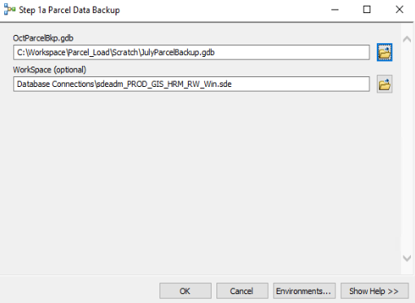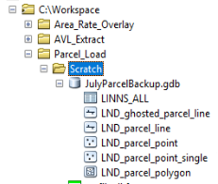
- Open Step 1b Parcel Preparation tool in the toolbox and make sure all the parameters are correct.
  - This script preps the data for loading into SDE (exports subsets, adds fields, checks geometry, etc.) and projects the data from ATS77 to NAD83.
  - This tool should take about 15-20 minutes to run.
  - These three shapefiles come from the downloaded zipped file from the province
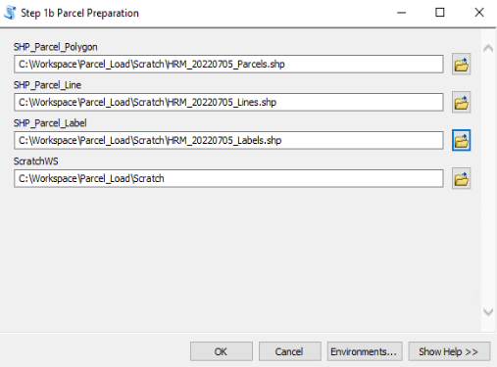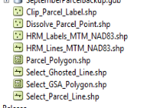
- At this point the Scratch workspace should look something like the following:
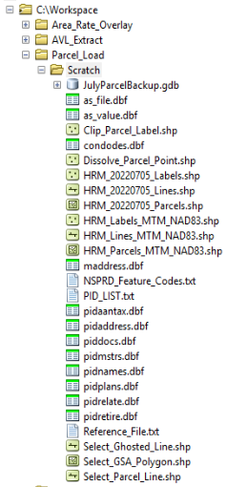

- Using ArcGIS Pro, compare the new parcel features with current (backup) data.
  - Overlay the old data with the new and do a visual check.
  - Compare feature counts.

Section 2

Load into Read Write and Read Only SDE databases. This should be completed before 8:30am Monday morning.

- MANUAL STEP: Backup LND_parcel_point feature class.
  - Open ArcCatalog and navigate to LND_parcel_point in the RW database.

- Export this as a shapefile called LND_parcel_point_old.shp and save it at C:\Workspace\Parcel_Load\Scratch.

- Truncate the feature class LND_PARCEL_POINT_OLD in SDE RW.

- Truncate and load LINNS tables on RW and RO databases.
  - Open ArcCatalog and navigate to the T:\work\giss\tools\Parcel Load\Parcel_Load.tbx

  - Open Step 2 Truncate LINNS Tables tool in the toolbox and make sure all the parameters are correct.
    - You will have to select the connection files for SDEADM_RW and SDEADM_RO.
    - This tool should take about 5 to 10 minutes to run.
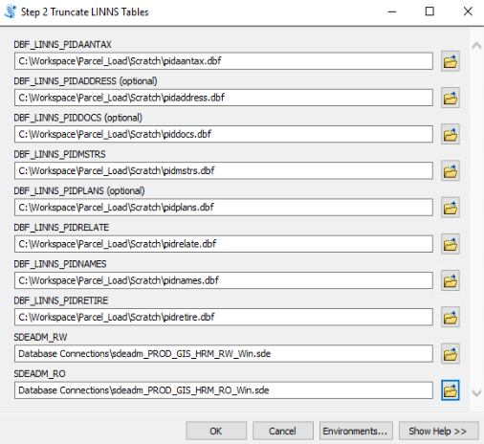

  - Click OK to run the tool. This tool performs the following tasks:
    - RWSDE:
- Truncates and Loads LINNS_PIDAANTAX
- Truncates and Loads LINNS_PIDNAMES
- Truncates and Loads LINNS_PIDRELATE
- Truncates LINNS_PIDMSTRS

    - ROSDE:
      - Truncates and Loads LINNS_PIDAANTAX
      - Truncates and Loads LINNS_PIDNAMES
      - Truncates and Loads LINNS_PIDRELATE
      - Truncates and Loads LINNS_PIDADDRESS
      - Truncates and Loads LINNS_PIDDOCS
      - Truncates and Loads LINNS_PIDMSTRS
      - Truncates and Loads LINNS_PIDPLANS
      - Truncates and Loads LINNS_PIDRETIRE

  - MANUAL STEPS: Once tool has completed, manually load the LINNS_PIDMSTRS feature class into the RW database with the data in the pidmstrs.dbf table from the province.
  - Map SDEADM.LINNS_PDMSTRS_AREA = AREA
    - Ensure all Area values are present. Using Pro the values were blank so had to use ArcCatalog. You can tell Pro what field to use, but doesn’t take it…

    - Two fields are mapped to none (LANDREL_CD and UPD_Date are set to none)
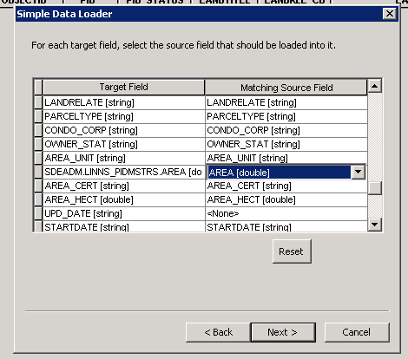

- Truncate and Load Spatial Data in the RW database.
  - Open ArcCatalog and navigate to the T:\work\giss\tools\Parcel Load\Parcel_Load.tbx

  - Open Step 3 Truncate and Load Spatial Data READWRITE tool in the toolbox and make sure all the parameters are correct.
    - You will have to select the connection file for SDEADM_RW.
    - This tool should take about 15 to 20 minutes to run.
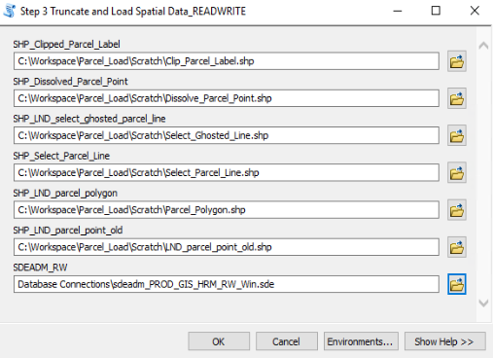

  - Click OK to run the tool. This tool performs the following tasks:
    - RWSDE
      - Truncates RW_LND_parcel_point_old
      - Truncates RW_LND_parcel_point_single and loads SHP_clipped_parcel_labels
      - Truncates RW_LND_parcel_point and loads SHP_Dissolved_parcel_point
      - Truncates RW_LND_ghosted_parcel_line and loads SHP_Select_Ghosted_Line
      - Truncates RW_LND_parcel_line and loads SHP_Select_Parcel_Line
      - Truncates RW_LND_parcel_polygon and loads SHP_Parcel_polygon

  - MANUAL STEP: Manually load LND_parcel_point_old.shp into LND_parcel_point_old feature class into the RW SDE database.

- Run SQLs statements to process data.
  - Open a command prompt and cd to T:\work\giss\tools\Parcel Load\Parcel Load sqls
    - You will need to map the T: drive if working from the server.

  - Open an SQLPLUS session as SDEADM user:
    - SQLPLUS
      - Username: sdeadm@'msgisorap201:1504/GISRWP01’
      - Password: Found in the GIS admin password excel file (H:\GIS\Contractors).

  - The list of SQL scripts that will be used in this section can be found at T:\work\giss\tools\Parcel Load\Parcel Load sqls. The list is also in the screenshot below:
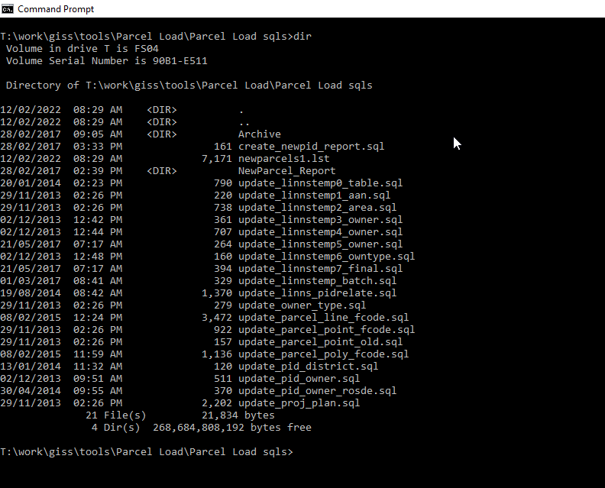
  - In SQLPLUS run the following scripts:
    - Note: Use @ to run sql scripts in sqlplus (@create_newpid_report.sql)

- @create_newpid_report.sql
  - This creates the following new file:
    - T:\work\giss\tools\Parcel Load\Parcel Load sqls\newparcels1.lst
  - Email this new file to the following people:
    - Gerrior, Melanie <gerriom@halifax.ca>; Chapman, Sean <chapmas@halifax.ca>; Mills, Kirk <kirkm@halifaxwater.ca>; Mathew, Shiju <shijum@halifaxwater.ca>; caversj@halifax.ca; Francois.Malenfant@halifax.ca
  - RE: New Parcels

- @update_parcel_line_fcode.sql
  - This updates remainder of LND_parcel_line attributes
  - This might take time to run so just let it finish.
  - Might result in 0 updates. Might not need to run this part in the future.

- @update_parcel_poly_fcode.sql
  - This updates remainder of LND_parcel_polygon attributes.
  - This might take time to run so just let it finish.

- Rebuild PID_Locator_NAD83
  - Open ArcCatalog on DC1-GIS-APP-P22 as hrm\arcgis_server_accoun user.
  - Navigate to E:\HRM\Scripts\Python\Update_Geocoders\geocoders
  - Right click and rebuild PID_Locator_NAD83 locator.

- @update_linnstemp_batch.sql
  - This might take time to run so just let it finish.

- Truncate and Append LINNS_ALL in RW database.
  - Truncate LINNS_ALL.
  - Append LINNS_ALL_STAGE to LINNS_ALL using the Append tool.
    - Note:
      - LINNS_ALL_STAGE is not registered with GDB.
      - Assessment field might be double instead integer. Load tool will not work in this case so use Append tool.
      - LINNS ALL is a joined table to create the view that ppl use.
      - When loading LINNS_ALL from stage table, the mailing field has been dropped so it shows up as none.
    - Check that Assessment gets loaded.

- Truncate and Load Spatial Data in the RO database.
  - Open ArcCatalog and navigate to the T:\work\giss\tools\Parcel Load\Parcel_Load.tbx

  - Open Step 4 Truncate and Load Spatial Data READONLY tool in the toolbox and make sure all the parameters are correct.
    - You will have to select the connection files for SDEADM_RO and SDEADM_RW.
    - This tool should take about 15 to 20 minutes to run.
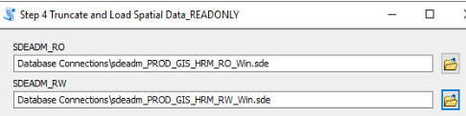
  - Click OK to run the tool. This tool performs the following tasks:
    - ROSDE
      - Truncates RO_LND_parcel_point_single and loads RW_LND_parcel_point_single
      - Truncates RO_LND_parcel_point and loads RW_LND_parcel_point
      - Truncates RO_LND_parcel_line and loads RW_LND_parcel_line
      - Truncates RO_LND_parcel_polygon and loads RW_LND_parcel_polygon

- MANUAL STEP: Truncate and load LINNS_PIDMSTR in the RO database.
*Make sure Area field gets populated
    - Truncate LINNS_PIDMSTRS.
    - Load LINNS_PIDMSTRS from RW database into LINNS_PIDMSTR in RO database.

  - MANUAL STEP: Truncate and load LINNS_ALL in the RO database.
    - Truncate LINNS_ALL.
    - Load LINNS_ALL from RW database into LINNS_ALL in RO database.

- If working on server MSGISAPPQ203, move all files from C:\Workspace\Parcel_Load\Scratch to your monthly folder on the file share so that there is an empty Scratch folder on this server for next month’s Parcel Load.

Cache Data Update

Update caching data on Caching Server = 15 minutes

- On the Caching Server DC1-GIS-APP-P21, run the Cache_Data_Update task in Task Scheduler.
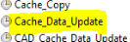

- Check the LND_parcel_polygon feature class in the following file geodatabase on the Caching Server to ensure that the data got updated with what you updated in RO.
  - E:\HRM\Data\Cache_Data\ AGOL_Halifax_Basemap_Data_WGS84.gdb

Hanson Updates

Create PID cross reference tables for Hansen = 60 minutes

- E-mail the Hansen Admin and notify them that the Hansen scripts can be re-run because the parcel load has been completed.
  - Wait to send this email until Tuesday so that the weekday nightly scripts have completed at least once.
  - Norma still likes to run her scripts but might not need to in the future due to POSSE.

Administrative Updates

30 minutes

- Update metadata for all updated parcel feature classes and tables in RW.
  - Use Metadata style format FGDC CSDGM Metadata.
    - To change style in ArcCatalog go to Customize Options Metadata

  - Updating in ArcCatalog:
    - Select applicable feature class.
    - Select Description tab.
    - Click Edit.
    - Update Revised Date in the Overview Citation Dates section.
    - Click Save.
    - Update the revision date for the following feature class in RW:
      - LND_parcel_polygon
      - LND_parcel_line
      - LINNS_ALL
      - LINNS_PIDANNTAX
      - LINNS_PIDMSTRS
      - LINNS_PIDNAMES
      - LINNS_PIDRELATE
      - LND_parcel_point
        - LND_parcel_point_single does get used so don’t bother updating revised date.
      - LND_ghosted_parcel_line

  - Update metadata for LND_parcel_polygon and LND_parcel_line in RO.

  - We may want to upgrade the metadata format before losing ArcMap/ArcCatalog
    - https://pro.arcgis.com/en/pro-app/2.9/help/metadata/upgrade-metadata-to-the-arcgis-format.htm

- Close Service Request

